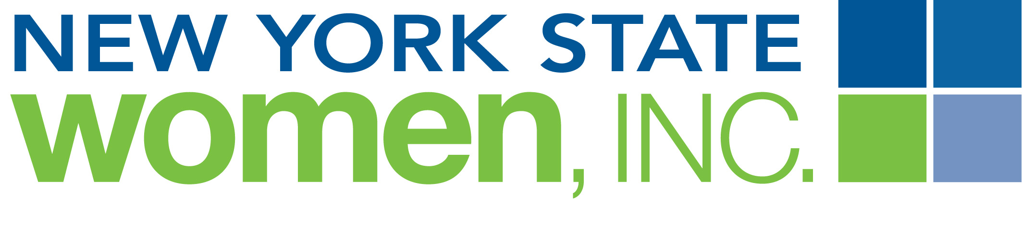

NIKE
The official publication of New York State Women, Inc.

NIKE Region & Local Chapter News

Publications Deadlines: July 15, October 15, January 15 and March 15

E-Mail Completed form to:
mailto:PR@nyswomeninc.org

Name of Region: Local Chapter:

Contact Person:

Telephone Number: Email:

Subject matter should relate to a NYSW, Inc. program, event or focus theme. Length of article should not exceed 150 words and may be edited as necessary. Local news must be typed (not hand written) and sent to the Associate Editor prior to copy deadline.

www.nyswomeninc.org

